**CREATION OF PROXY SERVER**

**Proxy Server:**

A Proxy server acts as an intermediary between client devices (such as computers or mobile devices) and the internet. It serves various purposes, including security, providing anonymity and improving performance.

**Squid Proxy Server:**

Squid is a widely used open-source proxy server that provides several features, including caching, access control and content filtering. It is commonly used to improve web server performance, reduce bandwidth usage and enhance security.

**Installing and Configuring Squid Proxy Server:**

**Command:** “sudo apt-get install squid”

Editing the squid configuration file to customize the proxy settings. The configuration file is typically located at ‘/etc/squid/squid.conf’. Adjust the configuration based on our needs.

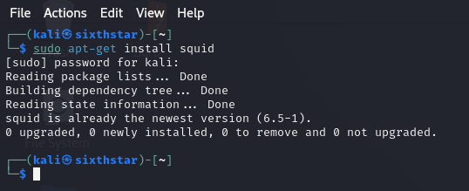

**Command:** “sudo nano /etc/squid/squid.conf”

**After configuring Squid, start the service:**

**Command:** “sudo service squid start”

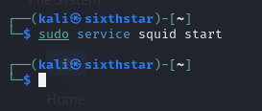

**Configure in the client devices:**

On the devices want to use the proxy, configure the proxy settings. In a browser, typically find this in the network or proxy settings. Set the IP address and port of the proxy server.

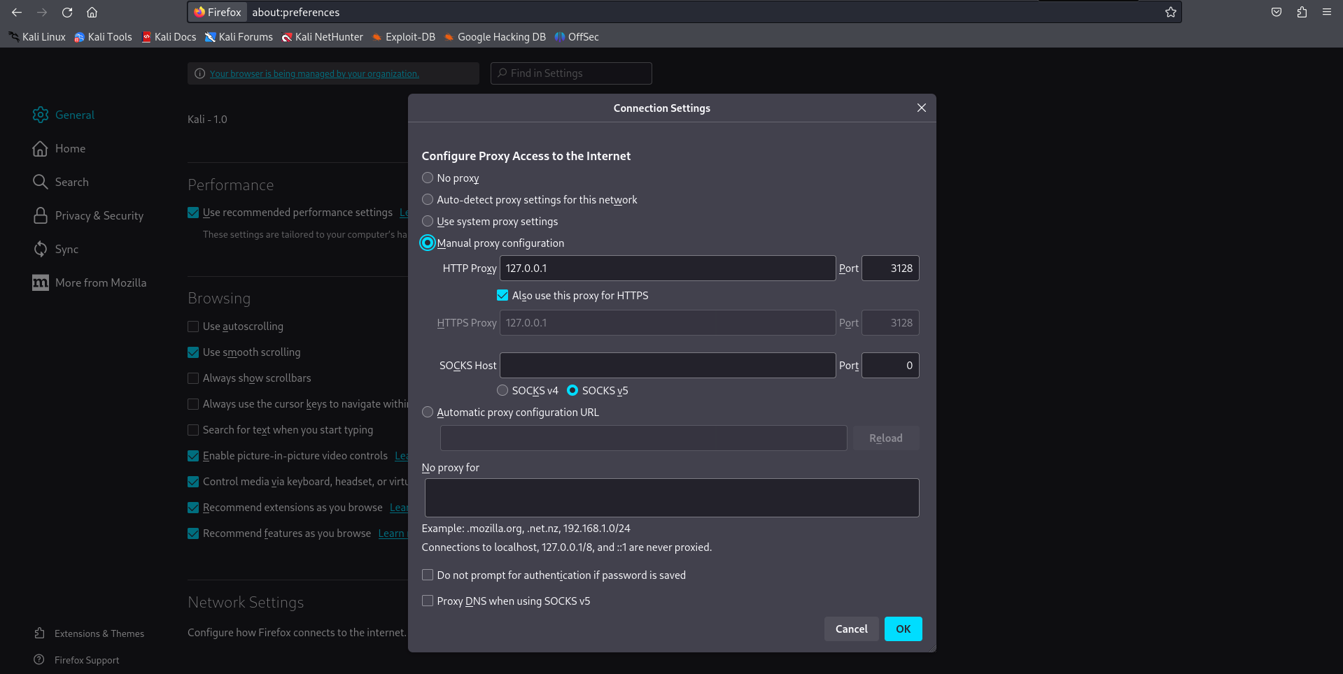

**Test the Proxy:**

By using the curl;

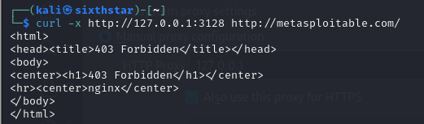

Open a web browser on a client device and verify that the proxy is working by accessing website.

